Incident and Response Manual

University of Advancing Technology
Wesston Dana
July 15, 2026

Introduction
Security incidents have become quite common in today's corporate environment because most companies use computer network and cloud-based technology in their operations. Various types of cyber incidents such as infections by malware, phishing, unauthorized access, or ransomware pose a great threat to businesses as they may interfere with operations and threaten the safety of sensitive data. As a result, every company needs to develop an incident response policy that will serve as a guide for dealing with various cyber threats. This document will define the procedure for handling incidents in Desert Shield Technologies.

Scope
The current policy applies to all employees, contractors, and temporary personnel who have access to company technology resources. This includes desktop computers, laptops, servers, network equipment, wireless networks, email system, mobile devices, and cloud computing systems. All individuals working in the company are supposed to follow this policy and report any suspicious activity to the Information Technology (IT) department. In addition, the policy highlights the roles and responsibilities of the IT Administrator and company management in incident response procedure.

Roles and Responsibilities
Effective handling of cybersecurity incidents is dependent on the clear assignment of responsibility for certain tasks. First, it is important to mention the employees' responsibility to report suspicious emails, unusual computer behavior, unauthorized access attempts, or any other strange activity. Employees should never try to investigate or remove malware themselves as such measures may destroy evidence.
The IT Administrator is responsible for investigating reported incidents, assessing the severity of the event, containing threats, collecting evidence, restoring affected systems, and documenting the process of handling the incident. Management is responsible for approving any major decision concerning recovery, communication with employees, and providing resources necessary for the incident response.

Incident Response Procedure
Desert Shield Technologies uses a simplified incident response plan that is based on NIST Incident Response Lifecycle. Preparation stage includes installation of updated antivirus software, enabling Windows firewall, installing operating system updates, performing regular system backup, and educating employees regarding cybersecurity. The preparation of systems and users prior to the occurrence of an incident decreases the possibility of successful attack and increases the effectiveness of response procedure.
Once a suspicious activity has been reported, IT Administrator starts the identification process by finding out whether there is a real security incident. Typical examples of such incidents include malware infection, phishing emails, unauthorized login attempts, loss of a device, or unusual network activity. At this stage, available information is collected and documented prior to making any changes to the affected systems.

In case a security incident has occurred, containment procedures should be performed in order to stop spreading the threat and additional damage. Depending on the type of an incident, different steps may be performed to contain the threat including isolation of affected computers from the network, deactivation of affected user accounts, blocking malicious IP addresses, or restriction of access to sensitive company resources. Preserving the evidence during the containment stage is crucial because it helps with further investigation and determination of the incident cause.
Eradication is focused on the removal of the cause of the incident. Such actions include deletion of malware, uninstallation of malicious software, installation of security updates, closure of vulnerabilities, password resetting, and scanning affected systems to find out whether the threat has been removed completely.
Recovery includes restoration of normal business operations through the connection of systems to the network, restoration of files from the backup, and verification of absence of malicious activity in the systems. After the threat has been eliminated, IT Administrator continues monitoring affected systems to make sure that they function normally and no other security incidents occur.
Finally, once the incident has been successfully resolved, lessons learned meeting is conducted in order to find out the effectiveness of the response. IT department assesses the cause of the incident, documents all actions that have been performed, identifies improvement possibilities, and makes updates to the incident response policy.

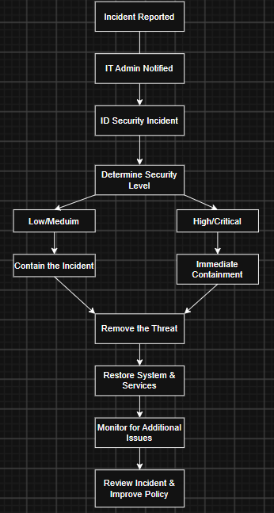

Incident Severity Levels
Every cybersecurity incident does not need the same level of response. Incidents that are considered to be minor, such as spam emails or accidental visiting of suspicious websites, usually do not require much investigation and employee education. Medium incidents include detection of malware infection on one workstation and also involve IT investigation and remediation but have little influence on company operations. High severity incidents include unauthorized access to the company systems or infections of multiple devices. Critical incidents may involve ransomware attacks or data breach and require immediate response at company level.

Incident Reporting
Reporting incidents is the crucial stage of the incident response process. All suspected incidents should be reported immediately to the IT Administrator. Report must include the date and time of the incident, affected device, the description of activity that has been observed, errors displayed on the screen, and screenshots. It is necessary to avoid investigation of suspicious files or removal of malware until instructions of the IT department have been received.

Policy Review
The rapid development of technology and cybersecurity threats makes policy reviews essential. The current incident response policy should be reviewed at least once a year or immediately after any major cybersecurity incident. Improvement suggestions and lessons learned from previous incidents must be used while updating the policy.

Conclusion
The current incident response policy provides a structured approach for handling cybersecurity incidents and minimizing damage to the company systems and data. The use of standardized procedures for preparation, identification, containment, eradication, recovery, and post-incident review helps with the effective response and decrease of downtime and increase of security. Assignment of responsibilities and reporting procedures help to ensure the understanding of employees about their role in cybersecurity protection.

References

National Institute of Standards and Technology. (2012). Computer Security Incident Handling Guide (Special Publication 800-61 Revision 2).
National Institute of Standards and Technology. (2024). Cybersecurity Framework (CSF) 2.0.

