Evaluation of Current Information Security Threats

University of Advancing Technology
Wesston Dana
July 15, 2026

Introduction
In the era of constant development of technology, organizations face a growing amount of different cybersecurity threats which might endanger confidentiality of sensitive information and disrupt operations. Hackers constantly create new ways of stealing credentials, encrypting data, and accessing computer systems. Due to those risks, organizations need to know about those dangers and implement appropriate security measures to ensure confidentiality, integrity, and availability of the organization's information. The report below covers several current cybersecurity threats, their possible influence on the security of organizations, encryption technologies that exist in modern world, and some safe security tests which were made for educational purposes.

Phishing and Credential Theft
One of the most widespread cybersecurity threats is the threat of phishing. It includes sending fraudulent emails, visiting websites, or downloading malicious attachments which are used to steal user's usernames, passwords, financial information, etc. Attackers often try to impersonate trusted people to make victims open those attachments or follow links which take users to malicious web pages. This type of threat can affect confidentiality of the information since attackers try to steal private information which should not be revealed to anyone else. Besides, if stolen credentials are used to access the computer of company or modify any company files or accounts, then integrity of the information may be affected too. Sometimes, if account is compromised by an attacker, he can cause some disruptions in business operations which will affect availability of computer systems. Organizations can prevent phishing attempts by using multi-factor authentication, security awareness training, email filters, password managers, and least privilege access control.

Ransomware
Ransomware has become one of the most devastating kinds of cybercrime which negatively affects many businesses. Ransomware differs from the conventional malware in the way that it encrypts the files of company and prevents legitimate users from using their information until ransom is paid. Most ransomware attacks also involve stealing information which is later being encrypted, therefore, if the company has backup copies of its information, then it is still harmed by ransomware. Ransomware affects all three elements of CIA triad. Confidentiality is endangered since attackers steal sensitive information which is later being encrypted. Information integrity is damaged since files are being altered or encrypted without consent of legitimate users. Availability is greatly reduced since users cannot use important company systems. Organizations can protect themselves from ransomware by making sure that there are secure backups of the information, antivirus software is enabled, operating system is up to date, multi-factor authentication is applied, and unnecessary administrative privileges are restricted.

Living-off-the-Land Techniques
In the modern world, the majority of attackers try not to use malware to conduct their malicious actions, but instead try to misuse legitimate tools of an operating system that are already installed on computers running Windows OS. This method of attack is known as Living-off-the-Land or LotL and helps to disguise malicious actions of attackers with legitimate actions of an administrator. In this way, attackers can use such utilities as PowerShell, WMI, Remote Desktop or schedule tasks to conduct their malicious actions while using legitimate system tools. The described issue is rather problematic due to the fact that many administrators would hardly distinguish legitimate activities from malicious activities. There are several ways to mitigate the risk of attackers misusing LotL techniques. It includes monitoring activity of PowerShell, limiting privileges of administrators, implementing centralized logging, checking remote access activities and application control policies which would prevent execution of unauthorized software.

Encryption Technologies
Encryption is considered to be one of the most effective methods of protection of sensitive information from any access. In order to protect data and stored information, modern organizations make use of encryption. In particular, AES is widely used for the protection of files stored on the hard drive. At the same time, TLS protects data transferred from computer to computer or web sites. Additionally, modern organizations use SHA-256 algorithm for cryptographic hashing. As the technologies keep developing, there are new standards for post-quantum cryptography developed to protect information from possible attack of quantum computers. Despite the fact that those technologies are yet to be implemented widely, they represent a considerable improvement in long-term information security.

Security Testing and Evaluation
There were several tests that did not represent any risk conducted in this project in order to illustrate the basic information security principles. The first test aimed at evaluation of integrity of files included calculation of SHA-256 hash before and after editing of a text file. Hash values became completely different after modification of the file.
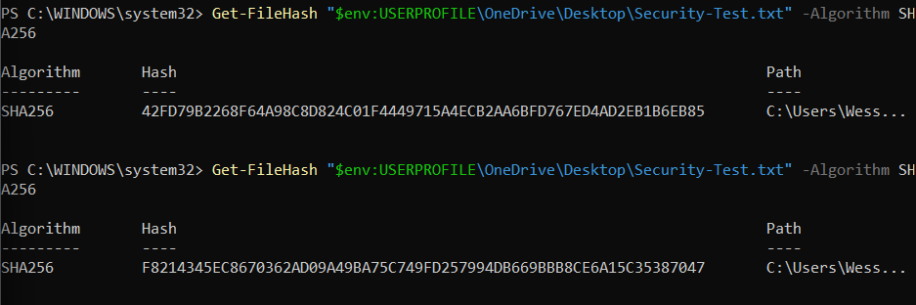
Test two checked the ransomware protection settings on the Windows computer through the examination of the Controlled Folder Access found on Windows Security. This function is helpful in preventing any unauthorized software from making changes to the protected files.
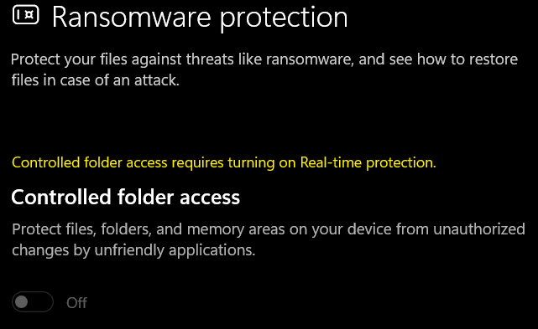
The third test involved the analysis of Windows Security Event Logs through looking at failed logon attempts. Failed authentications are recorded by the Windows operating system using Event ID 4625 and thus can be used in determining any cases of unauthorized logins. This is an important source of information when conducting investigations.
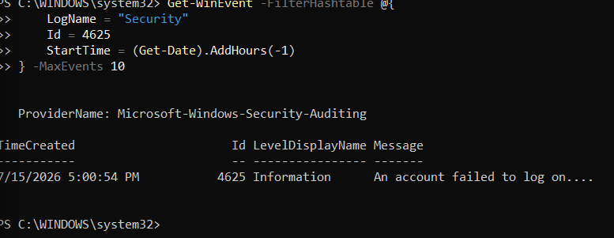
Final Test
The final test was conducted to determine whether encryption of Windows had been achieved. BitLocker is the process of encryption of stored information for securing data in case the computer gets lost or stolen. The status of the encryption showed whether the drive was protected through encryption or not.
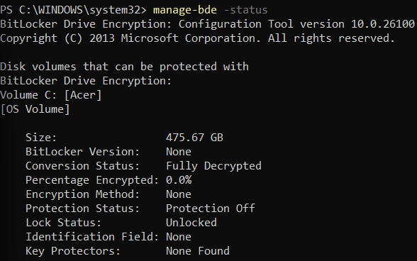
Testing Results
Test Performed | Security Principle | Expected Result | Actual Result
SHA-256 File Hash | Integrity | Hash changes after file modification | Hash value changed after editing file
Windows Ransomware Protection | Integrity/Availability | Controlled Folder Access status displayed | Protection status successfully verified
Failed Logon Event Review | Confidentiality | Event ID 4625 displayed when available | Security log reviewed successfully
BitLocker Encryption Review | Confidentiality | Encryption status displayed | Drive encryption status successfully verified

The results of all tests conducted have confirmed that all security controls work properly. In particular, the SHA-256 hashing demonstration has shown that any change in the content of a file creates a completely new hash value, thus confirming that the use of hashing is one of the methods of unauthorized modification. Windows Security has been used to check ransomware protection settings to assess one of the operating system's built-in security measures. Evaluation of Windows Security Event Logs has allowed checking how failed login attempts could be logged to monitor the security of the system. Finally, the assessment of BitLocker has proven the present status of encryption of the operating system drive.

Evaluation of Mitigation Techniques
No one security control is able to mitigate all types of cyber risks and threats. In order to decrease the risks, companies need to have a multi-layered approach and have several security controls to work simultaneously to mitigate cyber risks. For example, multi-factor authentication decreases risks in case of password cracking. Regular updates of software products decrease risks related to vulnerabilities that are exploited by hackers and attackers. Antivirus programs and endpoint detection programs allow decreasing risks related to installation of malware and ransomware. The use of encryption is required in order to increase confidentiality of sensitive data. It is worth mentioning that employee training on cybersecurity awareness issues is considered to be one of the most powerful security controls since many attacks start from phishing emails or social engineering.

Conclusion
Cybersecurity threats evolve, and information security becomes the continuous task of every organization. In the present project, such cybersecurity threats as phishing, ransomware, and Living-off-the-Land techniques have been considered while encrypting technologies have been analyzed. Moreover, several safe security tests have been done. In particular, the testing has shown how hashing ensures data integrity, how Windows Security allows checking ransomware protection, how event logging can help in security monitoring, and how BitLocker provides encryption of stored information.

References
National Institute of Standards and Technology. (2024). Cybersecurity Framework (CSF) 2.0.
National Institute of Standards and Technology. (2024). Post-Quantum Cryptography Standards.
Cybersecurity and Infrastructure Security Agency. (2025). Stop Ransomware Guide.
Cybersecurity and Infrastructure Security Agency. (2025). Identifying and Mitigating Living-off-the-Land Techniques.
Cybersecurity and Infrastructure Security Agency. (2025). LummaC2 Malware Advisory.

