Windows Security Audit and Assessment

University of Advancing Technology
Wesston Dana
July 14, 2026

Introduction
The main goal of the project was to design a PowerShell script that would help in automating Windows security audit. Instead of manually examining several security settings, the script can gather system information, assess security settings and generate the security audit report. Automating this task helps to save time, be consistent and detect security problems effectively. The created script makes a set of security assessments: status of Windows Firewall, status of Microsoft Defender, local user accounts, password policy, installed updates, network listening ports, shared folders, failed log on events and available disk space. Based on gathered information, the script assigns the security risk rating and generates three reports: HTML, TXT and CSV.

PowerShell Script Development
As an automation tool the project was implemented in Microsoft PowerShell as it comes with Windows and allows accessing built-in system administration and security management tools. The script contains functions performing individual security assessments and was written with the use of functions to make it easier to read, test and debug and demonstrate structured programming. Variables were used for storing system information, audit dates and results of assessment. Conditional statements were used to check whether individual security settings correspond to recommended ones, and loops processed arrays of data like firewall profiles, local user accounts, network ports and installed updates.
PowerShell Script:
Execution of Script
Once the script was ready, it was run on an elevated PowerShell session that had administrative privileges. The reason why administrative privileges were needed is because some security commands, such as Windows Security event logs and configuration checks, require elevated access. The execution policy of the PowerShell session was temporarily changed in order to be able to execute the script without affecting any security settings of Windows permanently. Once the script was run, it would automatically go through nine different phases of security checks.
Those phases included:
- System information gathering
- Windows Firewall check
- Microsoft Defender check
- Local user accounts review
- Password policy check
- Updates installation check
- Network port check
- Failed logon events check
- Disk space check
- Security report generation

This automation allowed avoiding manual work for all these administrative procedures.
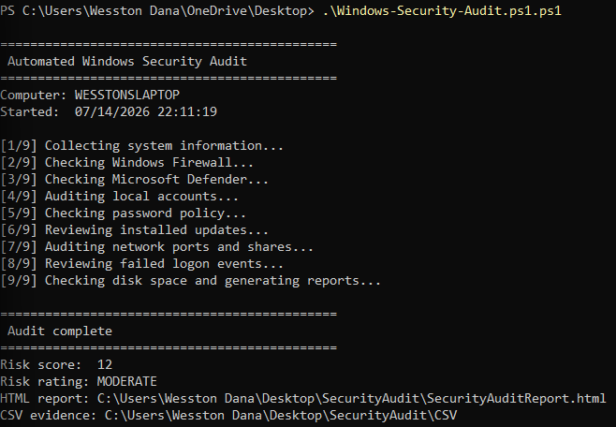
Security Assessment
As a result of execution, the script performed an analysis of several critical security components of the operating system. Firewall assessment included the verification of Domain, Private and Public Windows Firewall profiles. It is considered one of the main security controls, which prevents unauthorized traffic entering and leaving a computer via a network connection.
The script also performed the assessment of Microsoft Defender by determining the presence of antivirus and real-time protection enabled. Moreover, the script checked the date of the latest security definitions updates in order to see whether all malware signatures are updated. Local user accounts and members of Administrators groups were identified in order to find accounts that might pose unnecessary security threats. The script also reviewed the Windows password policy. Patch management was performed by the script through gathering data on recent Windows updates and verification of the availability of Windows Update service.

The network was analyzed in terms of listening TCP ports and shared folders that could potentially expose unnecessary services. Lastly, Windows Security Event Logs were checked for failed logon attempts.
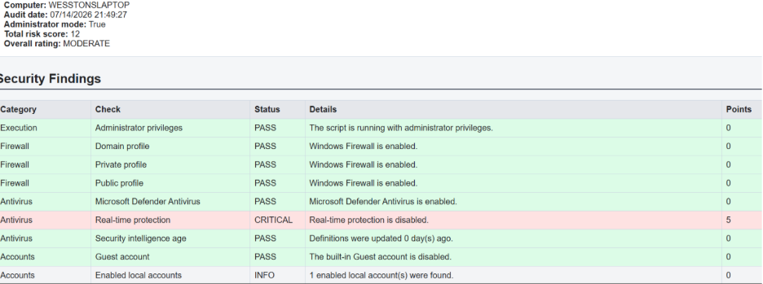

Automated Reporting
Automating security reporting was one of the main goals of this project. Not only was the information displayed within the PowerShell window, but also several reports in different formats were produced. The main report was in HTML format, which included summary data along with risk calculation based on this data. Several CSV reports with more detailed information on firewall configuration, updates, open ports, user account status, disk usage, and other security-related metrics were also produced. This way, administrators are able to assess the security of their systems without gathering all information manually from various Windows management tools.
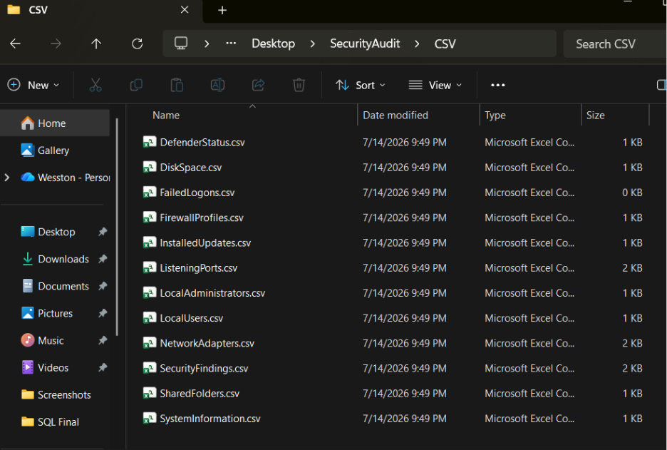

Tests and Validation
Upon the completion of the initial auditing process, the findings were evaluated in order to check if the developed script contained the current security configuration of the computer. The output reports were compared against such Windows management systems as Windows Security, Microsoft Defender, Windows Update, Local Users and Groups, etc. It was found out that the information contained in the reports coincided with the actual state of the computer security configuration and, therefore, proved that the script obtained the relevant information correctly. In addition, a controlled test was performed where one of the security settings was changed, and the script was executed. The test report contained a detection of the configuration change and an increased security risk. Once the test was over, the initial configuration was restored, and another audit proved that the state of the computer had been returned to normal.
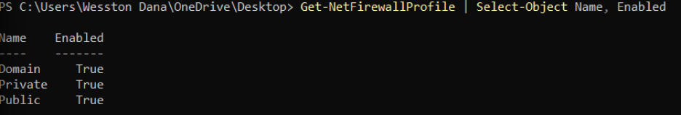
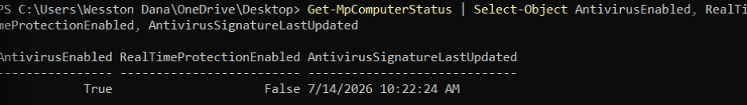
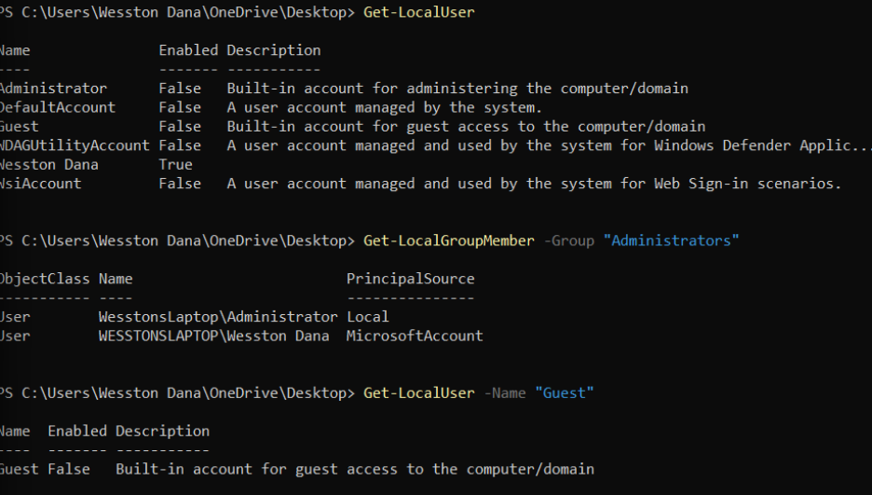
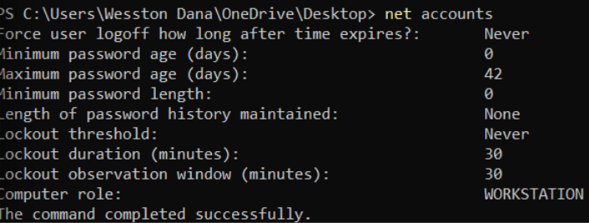
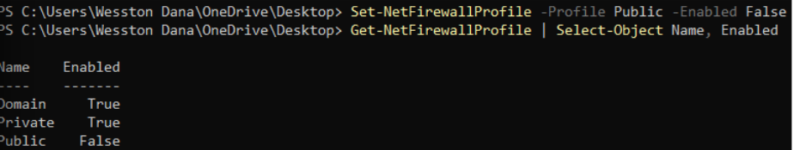
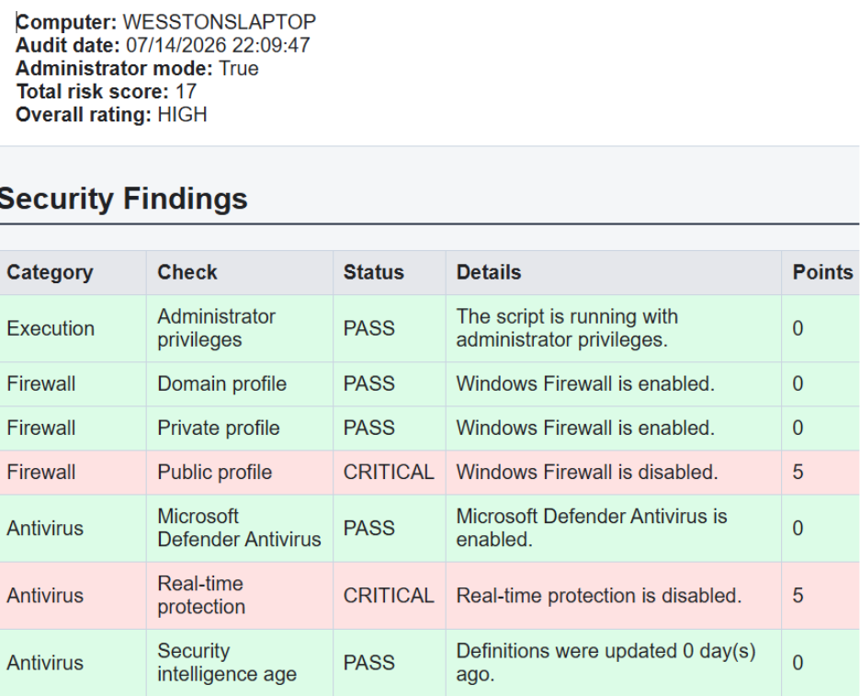

Results
The security audit was successfully performed by the automated tool. The script was able to create a complete list of key security settings of Windows and generate various report formats which could be used in the future analysis. The project showed the possibility of automation of security administration tasks which would take much effort if done manually. In contrast to the process of opening several Windows management consoles, the script was able to collect all necessary data automatically and present it in professional reports. Moreover, the project proved knowledge in practical PowerShell scripting, Windows administration, system auditing, security analysis, report generation, and automated assessment.

Conclusion
This project successfully achieved all of the goals set by the degree objective. It was possible to create, implement, and document an automated tool for security auditing using PowerShell. The script performed the automation of various administration and security-related processes like firewall checking, antivirus testing, user accounts auditing, password policy checking, patch management checking, network analysis, and event logs auditing. The ability to generate reports automatically helped to reduce the time needed to perform the security audit and increased the quality of the process.

References
Microsoft. (2025). PowerShell documentation. https://learn.microsoft.com/powershell

Microsoft. (2025). Microsoft Defender documentation. https://learn.microsoft.com/defender/

Microsoft. (2025). Windows Security documentation. https://learn.microsoft.com/windows/security/

